Advanced Engineering Mathematics, by Erwin Kreyszig 10th. Ed.

**Problem Set 2.9**

No. 1

 (1’) R, C and E are all constants.

Differentiate (1’) with respect to t



 k is any constant

At t＝0,  

Particular sol. 

No.2

 (1’)

Differentiate (1’) with respect to t







 k is any constant

At t＝0,   



Particular sol. 



No. 3

 R, L and E are all constants.



 k is any constant

And  

Particular solution 

If L＝0.5H, R＝20Ω, E＝110V



No. 4







 k is any constant

Since at t＝0, I＝0 



Particular sol. 

No. 5

 (1’)

Differentiate (1’) with respect to t







As  



Now 





General sol. (a)

 (b)

As  and 

From (1’)  



Substitute the initial conditions,and  into (a) and (b) respectively





Particular sol.

No. 6

 (1’)

Differentiate (1’) with respect to t

 (1)



Set 

We substitute    into (1)

  





Now 





General sol. (a)

 (b)

Substitute the initial conditions,and [ie] into (a) and (b) respectively





Particular sol. 

No. 7

** ** minimum(＝ 0),  maximum

 

No. 8











No. 9





 Steady-state current＝0

No. 10





 

Steady current (安培)

No. 11



 (1’) Differentiate (1’) with respsct to t



The corresponding homogeneous ODEs 











Set 

 

 



General sol. 

No. 12



 (1’) Differentiate (1’) with respsct to t



The corresponding homogeneous ODEs 











Set

 







General sol. 

No. 13









Set

 







General sol. 

No. 14



(i)  is real and 

 as 

(ii)  is real and 

 as 

(iii) 

 

 as 

No.15













Critical resistance 

No. 16







(double root)







Set 





 



General sol. 

 

Initial values 



At t = 0 

Since 

Insert into (a), into (b).





Particular sol. 

No. 17



















Set 





Substitute  into (1)









 

 



General sol. 



Initial values 



At t = 0 

Since 

Insert into (a), into (b).





Particular sol. 

No. 18









 (1)

Set 





Substitute  into (1)





  (2)

  (3)

(2)×+(3)× 



(2)×－(3)× 



Let 

Then 



 



General sol. 



And  

Since  

Insert into (a),  into (b).

  (4)

  (5)

(4) ×4 + (5) →  

Insertinto (4) 

Particular sol. 

No. 19

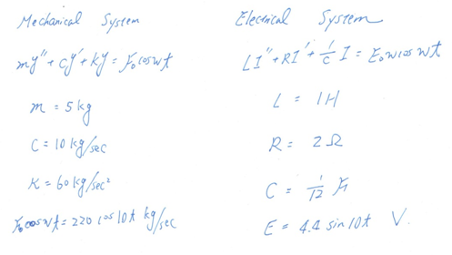

No. 20

 (1)

Set   

Substitute  into (1)







 (Let)

Since 

Real part is 

